FALL 2024  
MEC325: INTRODUCTION TO ENGINEERING DESIGN  
DESIGN PROJECT  
**PRODUCT DESIGN SPECIFICATION**



Assistive Transport of Children

when Walking

TEAM 1305

# team declaration

We, the undersigned members of Team SSNN in MEC325, agree that:

* all team members have abided by all Ryerson Policies and course rules, and
* one of our members has shared a properly completed Workload Distribution Form with our Teaching Assistant and our instructor.

We furthermore accept that any violation of Ryerson Policy or course rules will lead to a grade penalty or charges of academic misconduct.

| STUDENT NAME | STUDENT NUMBER[1] |
| --- | --- |
| Osman Asif | 35477 |
| Codin Nguyen | 37911 |
| Osama Noureddin | 46598 |
| Khiem Nguyen | 13735 |
| Andrej Draskovic | 32844 |
| Yee Yin Kwok | 51256 |

# table of contents

team declaration 1

table of contents 2

Loop 1 1

design Concept 1. 1

design Concept 2. 5

design Concept 3. 8

design Concept 4. 14

design Concept 5 18

design Concept 6 22

Loop 2 26

design concept 1 26

design concept 2 29

design concept 3 32

design concept 4 35

design concept 5 38

design concept 6 41

# Loop 1

## design Concept 1.

Osman Asif’s Design concept

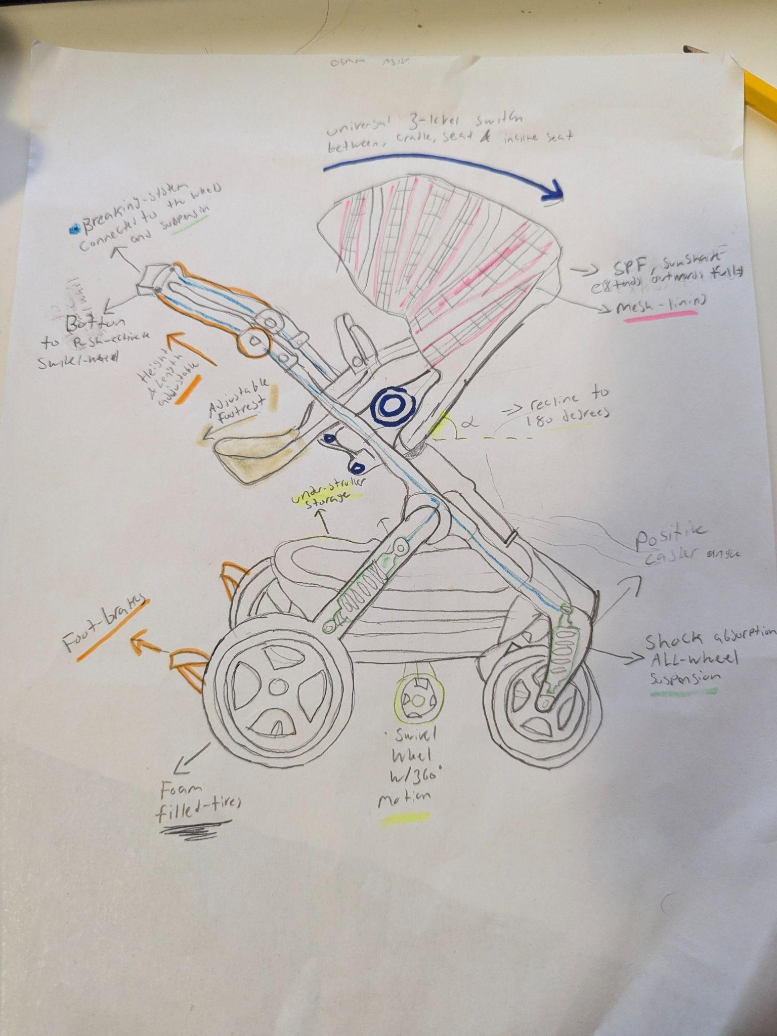

**Description**

The design shows a four-wheel stroller that has the ability to recline to a full 180 (highlighted angle) degrees to allow the seat to transform from a seat to a cradle (dark blue) while providing the maximum amount of comfortability for both the child and the parent. It can also change from facing towards the parent to facing away, given the modular seat design. Furthermore it allows for more versatility when dealing with a growing child, making it a universal stroller that is not in need of replacing by incorporating a height adjustable seat to allow for even more customization, an adjustable footrest is also included that ensures the safety of the child by not allowing any dangling feat and a comfortable resting position that promotes a positive pelvic position. Furthermore, the adjustable handlebar (orange) allows for the parent to comfortably push the stroller with a neutral wrist position. The mesh-lined sunshade(pink) prevents harmful UV rays from constantly shining on the child and allows for proper ventilation through the mesh lining and can fully encase the seat in order to protect the child from any harmful weather conditions. The foot brake system allows for long stops when the stroller is not in motion and is rather parked. The push-activated brake connected to the wheels & suspension system(green) through a brake line (blue line) that is incorporated into the frame, allowing for sudden, but safe stops when needed. Furthermore the four-wheel system incorporates foam-filled tires that along with the suspension system create an enjoyable and comfortable ride by reducing the shock and vibrations that can be experienced. Moreover, through the use of the brake system, pushing down further can release the swivel wheel that can allow for maneuverability in tight spaces and when sharp turns are involved.

**Usage scenario**

Setup

1. Easily unfold the stroller due to the 3-way locking mechanism
2. Adjust the handlebars to align with the waist
3. Adjust the footrest and seat height for the child
4. Add items to the under-stroller storage
5. Adjust the modular seat to face away from the stroller or towards

Use

1. Place the child into the stroller while also Adjusting the recline angle to accommodate the child
2. Make sure the stroller strap is secured and tightened
3. Adjust the mesh-line sunshade to reduce the amount of sunshine
4. Push the stroller, the suspension system absorbs any shocks or vibrations
5. Immediate stops can occur with the push-activated stroller breaks on the handle
6. Permanent stops can occur with the foot-brakes
7. The swivel wheel can be activated with the push-brake to accommodate maneuverability in tight spaces
8. Use the under-stroller storage space to place any essential items

Put away

1. Make sure the child is out of the seat, while also ensuring the adjustable seat is locked in a fixed position so that it won’t move
2. Make sure that the foot brake is engaged and the swivel wheel is disengaged
3. Lock in the seat at a 60 degree angle(position found in the design), Starting by removing the storage
4. Release all three locks of the seat and push downwards
5. fold the stroller
6. Store the stroller

| Demand Type | US Step # (Most demanding task) | Demand Level | Notes |
| --- | --- | --- | --- |
|  | **SET UP** |  |  |
| Perceptual | 1a | 2 | 3-way locking system requires awareness and touch |
| Cognitive | 1c | 2 | Requires thought about the comfortability of the child especially as they grow |
| Physical | 1e | 3 | Requires physical force in order to move the seat to face the other direction |
|  | **USE** |  |  |
| Perceptual | 2c | 1 | Requires perception on how much sun is being shined on the child, and how much to extend out the shade |
| Cognitive | 2g | 3 | Requires a unique solution to maneuverability in tight spaces, yet something uncommon, so it requires decision making on when to use |
| Physical | 2d | 2 | The suspension and foam filled wheels allow for a smoother ride however to push the stroller is still physically demanding |
|  | **PUT AWAY** |  |  |
| Perceptual | 3c | 2 | Use of vision to ensure the seat is angled properly and locked in place |
| Cognitive | 3d | 3 | Needs careful coordination to unlock all 3 mechanisms and to fold in the right sequence. |
| Physical | 3e | 2 | Somewhat physically demanding to place the stroller in a storage area |

## design Concept 2.

Osama Noureddin’s Design Concept

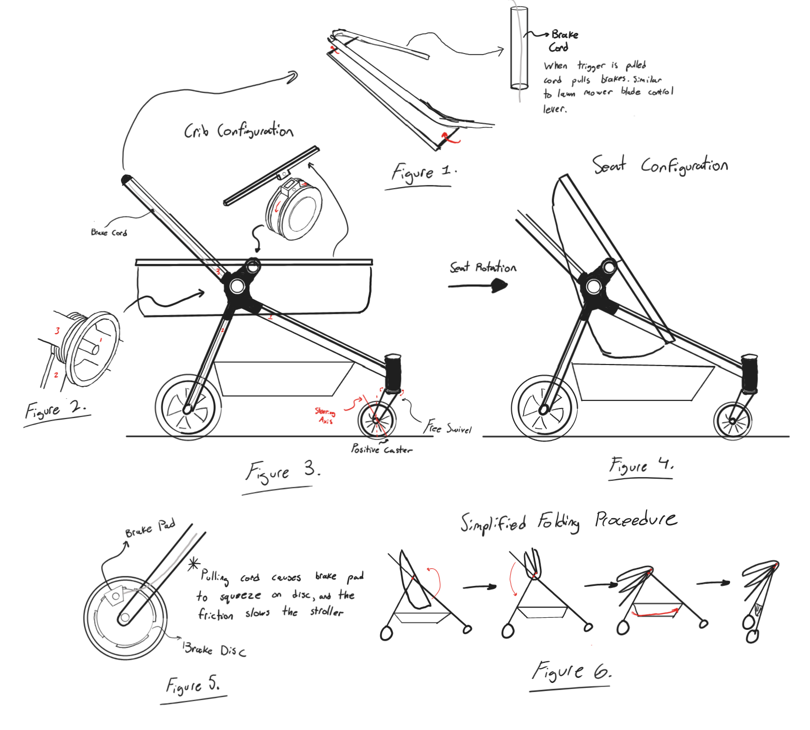

**Description:**

The design concept sketch illustrates a four-wheel stroller design that integrates various features, most prominently a transformable seat that goes from a crib to seat, as seen in *Figure 3 and 4*. This allows the stroller to last multiple years as the child grows older, without the need for an additional stroller to be purchased. Also featured on the stroller is a storage compartment underneath the seat, which would be made entirely of fabric and be attached to a rod connecting the left and right side of the frames. The fabric would allow for changing of shape when folding. The stroller also features a folding mechanism for storage that works through two points of rotation as shown, one for the seat/crib and one for the chassis and handlebars. A visualization of the folding procedure can be seen in *Figure 6*. The two front wheels of the stroller are swivel wheels with positive caster (see [SKB 5.5](https://docs.google.com/document/d/1YEjEXJfWXH6WhaKF20ACS39N4-rEMIp-a03EXtmuQ7s/edit) for wheel caster), while the two rear wheels are fixed. Also not clearly shown in the sketch are the seatbelts, which serve an important purpose in keeping the infant from falling out of the stroller and are an essential safety feature. Lastly, the rear wheels also feature an active braking system, that is activated via a brake cord similar to that on a bicycle that runs through the hollow chassis. The brakes are activated through a squeezable bar on the handle, which takes inspiration from the blade control levers found on many gas-powered lawn mowers.

**Usage Scenario:**

1. Setup
   1. Unfold the stroller by unlocking the chassis lock and rotating the seat/crib and handlebar into position as shown in Figure 6.
   2. Ensure that the seat/crib is properly configured based on the child's age.
   3. Secure the brake cord by checking the handlebar level is properly in place and working to engage/disengage the brakes.
2. Use
   1. Place the child securely in the seat or crib, adjusting the seat as needed.
   2. Ensure that the seat belts are securely fastened around the child.
   3. Begin pushing the stroller.
   4. If you need to slow down or stop, pull on the brake handle to engage the bake cord mechanism.
   5. Utilize the fabric storage compartment underneath for carrying personal items, ensuring it doesn’t interfere with stroller operations.
3. Put-Away
   1. Ensure the child is out of the seat/crib and is at a safe distance, and ensure there are no items left in the storage compartment.
   2. Fold the stroller by first collapsing the seat/crib and handlebar using the folding procedure outlined in Figure 6.
   3. Lock the chassis into the folded position for easy storage or transport.
   4. Store the stroller in an appropriate place, ensuring it is secure and out of the way.

| Demand Type | US Step # (Most demanding task) | Demand Level | Notes |
| --- | --- | --- | --- |
|  | **SET UP** |  |  |
| Perceptual | 1c | 2 | Use of touch and vision to ensure seat is locked in place for safety |
| Cognitive | 1b | 1 | Familiarity with how brakes feel |
| Physical | 1a | 3 | Heavy lifting with two hands for support and back bending needed |
|  | **USE** |  |  |
| Perceptual | 2d | 3 | Good spatial awareness and eyesight needed |
| Cognitive | 2d | 3 | Good hand-eye coordination and quick reaction time needed to quickly grab brake bar |
| Physical | 2c | 2 | Strong push may be required depending on weight of infant and storage items |
|  | **PUT AWAY** |  |  |
| Perceptual | 3a | 3 | Awareness of surroundings sense of touch for unlocking safety features |
| Cognitive | 3b | 2 | Ability to understand steps in correct order to fold efficiently |
| Physical | 3c | 2 | Good physical control over the stroller with both hands needed |

# 

# 

## design Concept 3.

Codin Nguyen’s Design Concept

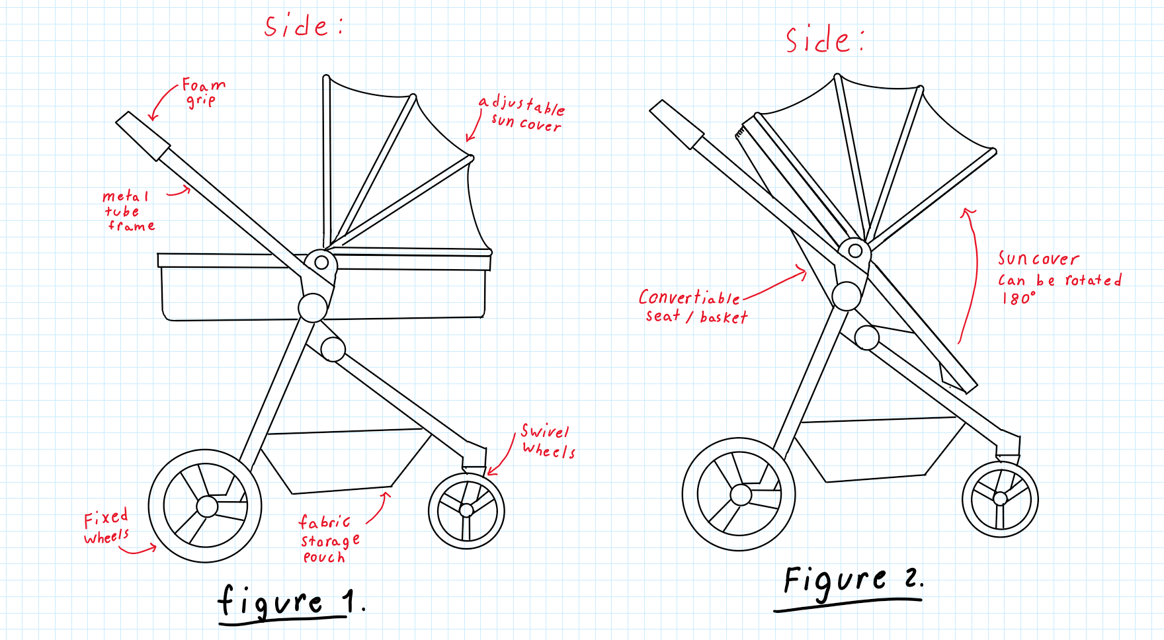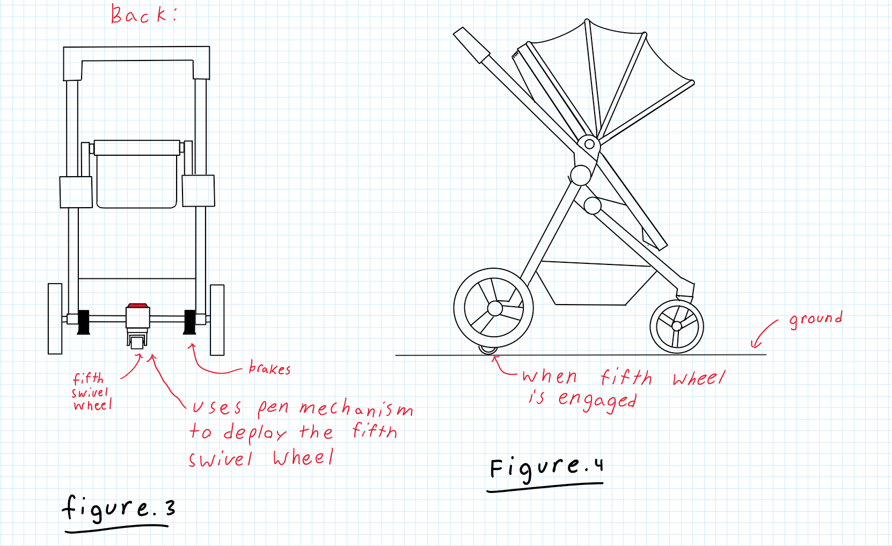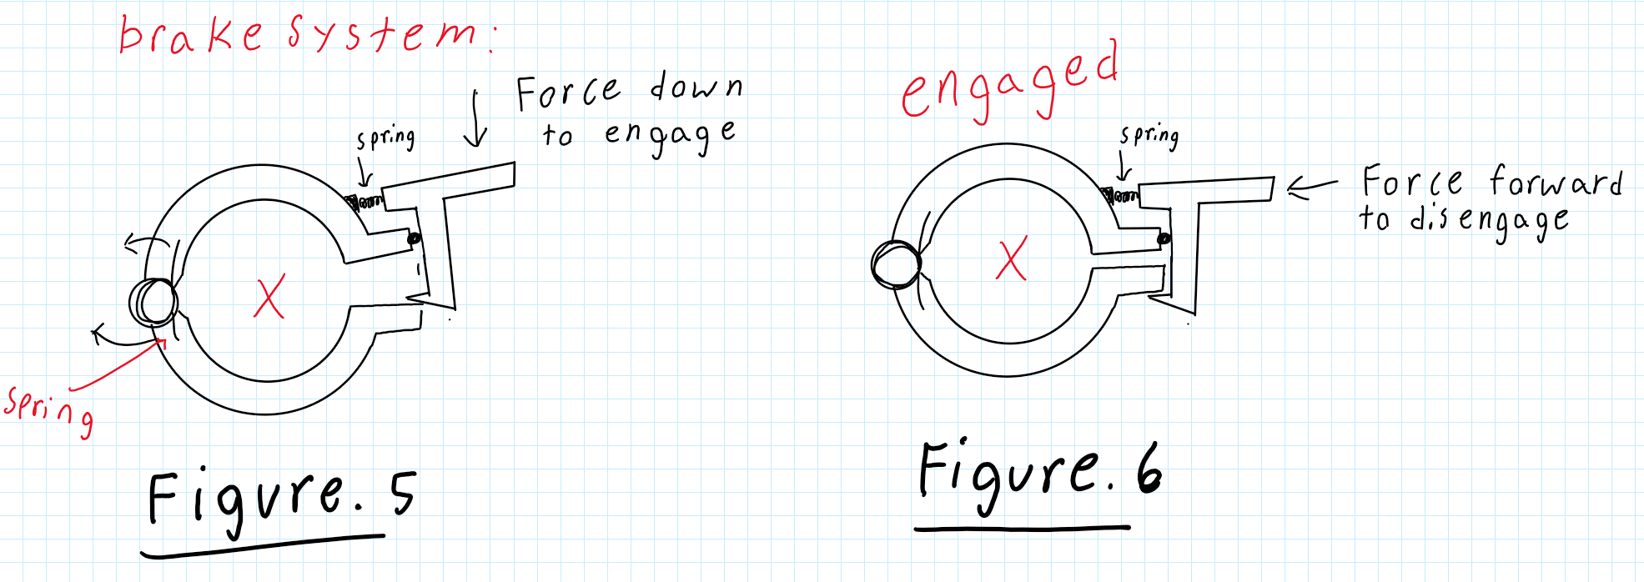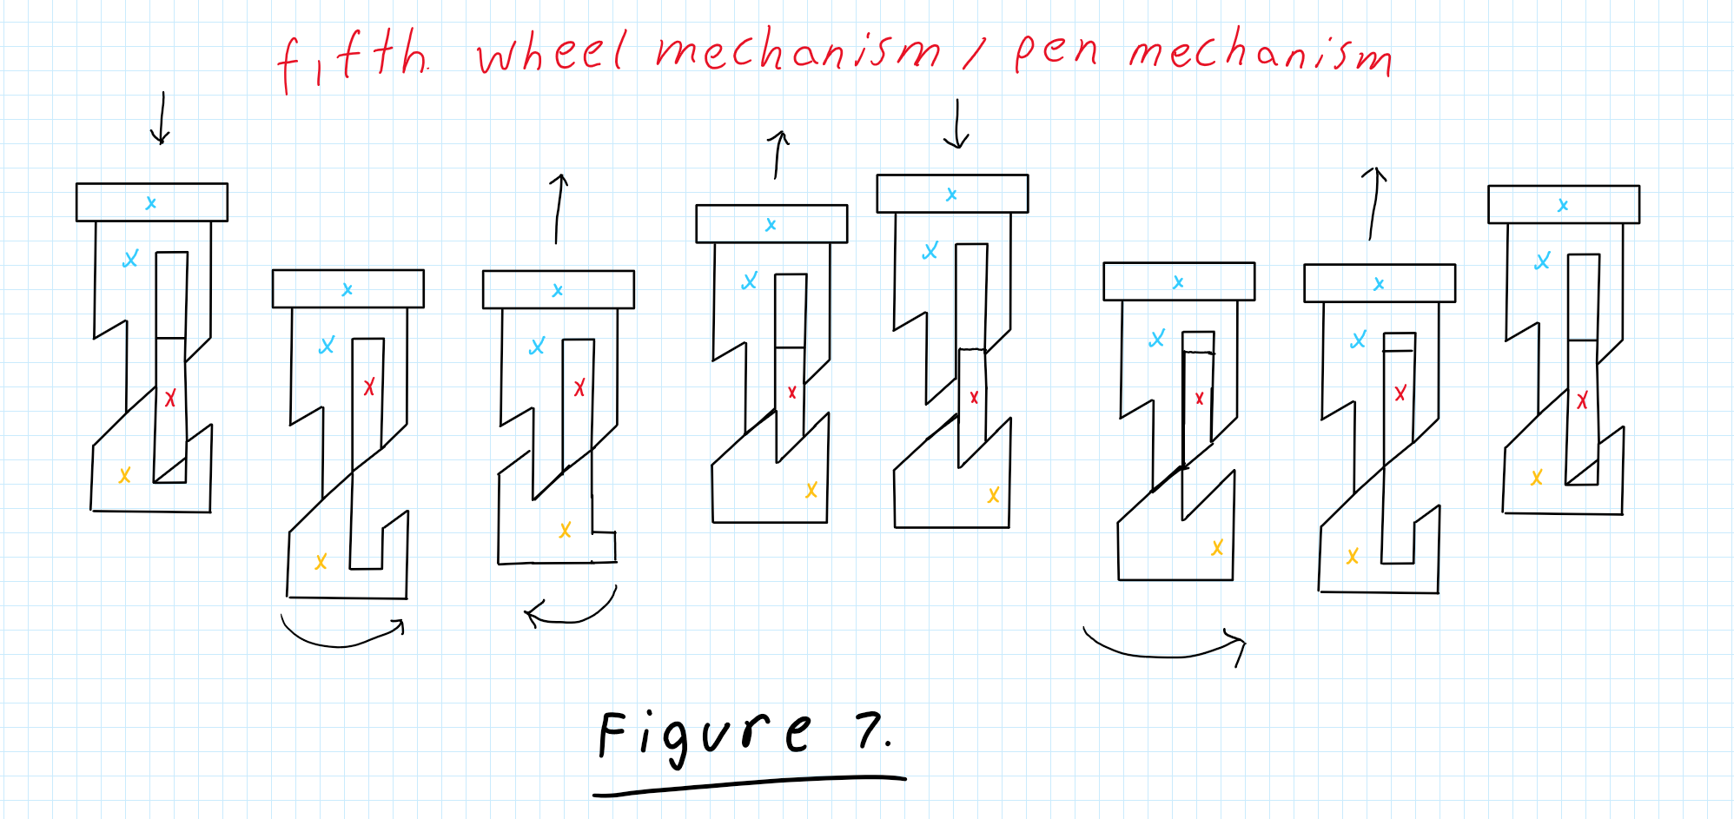

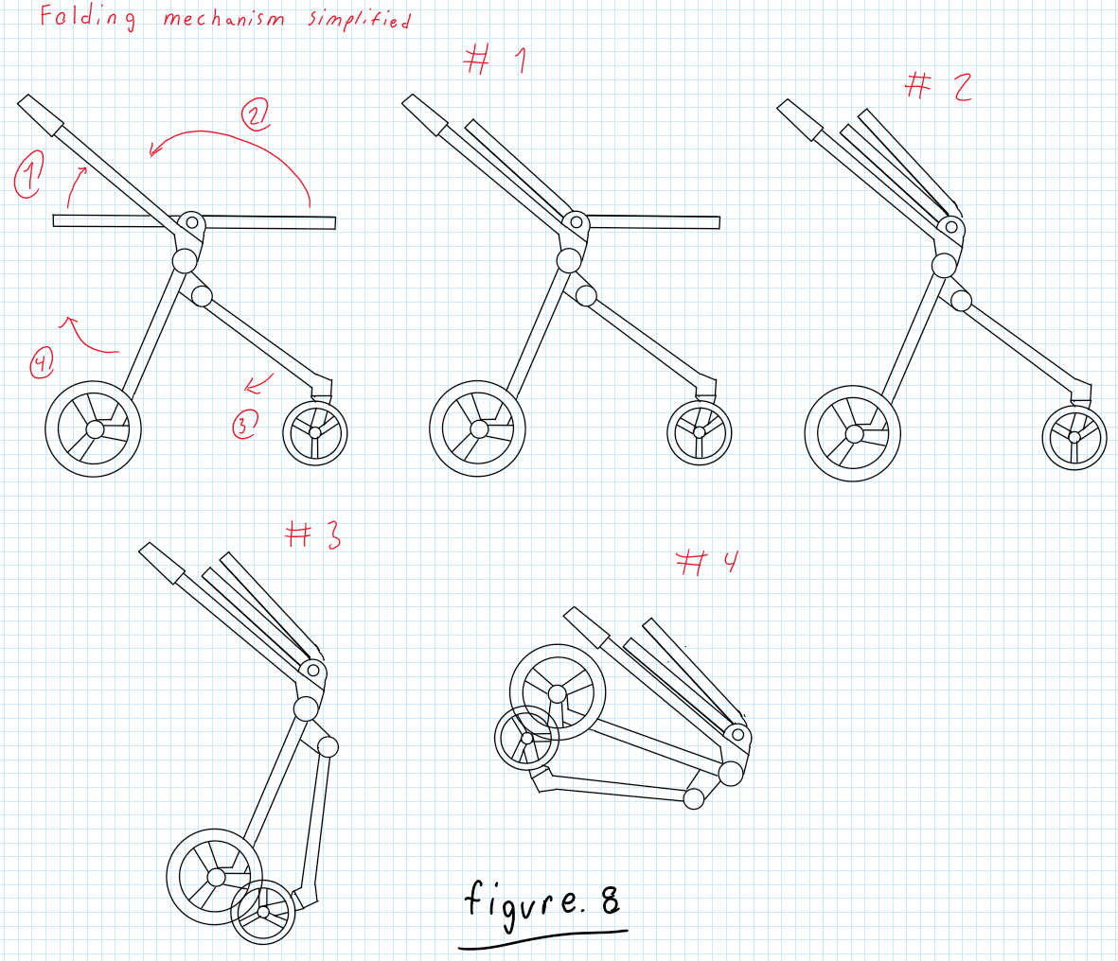

**Description:**

The design concept sketch presents a five-wheel stroller featuring several innovative elements, most notably a transformable seat that shifts from a basket to a stroller seat with a 40-degree incline (see Figures 1 and 2). This versatility allows the stroller to accommodate a growing child over multiple years, eliminating the need for a new stroller. A standout feature is the deployable fifth swivel wheel, activated by stepping on a red button. When engaged, this fifth wheel supports the stroller on its two front swivel wheels and a single rear swivel wheel, facilitating omni-directional movement, which is particularly beneficial in confined spaces like public transport (see Figure 4). To retract the fifth wheel, users can press the red button again, causing it to retract smoothly like a pen. When the fifth wheel is disengaged, the stroller moves on two front swivel wheels with positive caster (see SKB 5.5 for caster specifications), while the two rear wheels remain fixed. The design also includes a braking system, activated by applying force as demonstrated in Figures 5 and 6, allowing users to lock the stroller in place—an essential feature for safety on public transport or inclined surfaces. The stroller incorporates a folding mechanism for easy storage and transport. Additionally, a seatbelt is integrated for child safety, preventing toddlers from falling out while the stroller is in motion.

**Usage Scenario:**

1. Setup
   1. Unfold the stroller as shown in figure 8.
   2. Ensure that the seat/basket is properly configured based on the child's age.
2. Use
   1. Place the child securely in the seat or crib, adjusting the seat as needed.
   2. Ensure that the seat belts are securely fastened around the child.
   3. Disengage the stroller breaks shown in figure 5 and 6
   4. Begin pushing the stroller.
   5. Utilize the fabric storage compartment underneath for carrying personal items, ensuring it doesn’t interfere with stroller operations.
   6. To engage the omnidirectional mode step on the red button located between the two back wheels.
   7. To disengage the omnidirectional mode step on the red button located between the two back wheels.
3. Put-Away
   1. Ensure the child is out of the seat/crib and is at a safe distance, and ensure there are no items left in the storage compartment.
   2. Fold the stroller by first collapsing the seat/crib using the folding procedure outlined in Figure 8.
   3. Store the stroller in an appropriate place, ensuring it is secure and out of the way.

|  |  |  |  |
| --- | --- | --- | --- |
| Demand Type | US Step #  (Most demanding task) | Demand Level | Notes (including what drives the demand) |
|  | **SET UP** |  |  |
| Perceptual | 1a | 2 | Requires visual confirmation of correct unfolding |
| Cognitive | 1b | 3 | Proper sequence needed for assembly based on child's age |
| Physical | 1a | 3 | forceful bending and lifting movements needed; needs two handed manipulation |
|  | **USE** |  |  |
| Perceptual | 2b | 2 | Visual and tactile input needed to ensure correct belt fastening |
| Cognitive | 2f/g | 2 | User must recognize and understand the button for mode change |
| Physical | 2d | 3 | Requires continuous force application and maneuvering control, especially over uneven surfaces |
|  | **PUT AWAY** |  |  |
| Perceptual | 3b | 3 | Requires visual confirmation ensure no child or items remain inside |
| Cognitive | 3c | 2 | Understanding folding steps and sequence is needed |
| Physical | 3d | 3 | Requires strength to lift and position stroller securely |

# 

# 

# 

# 

## design Concept 4.

Andrej Draskovic’s Design Concept

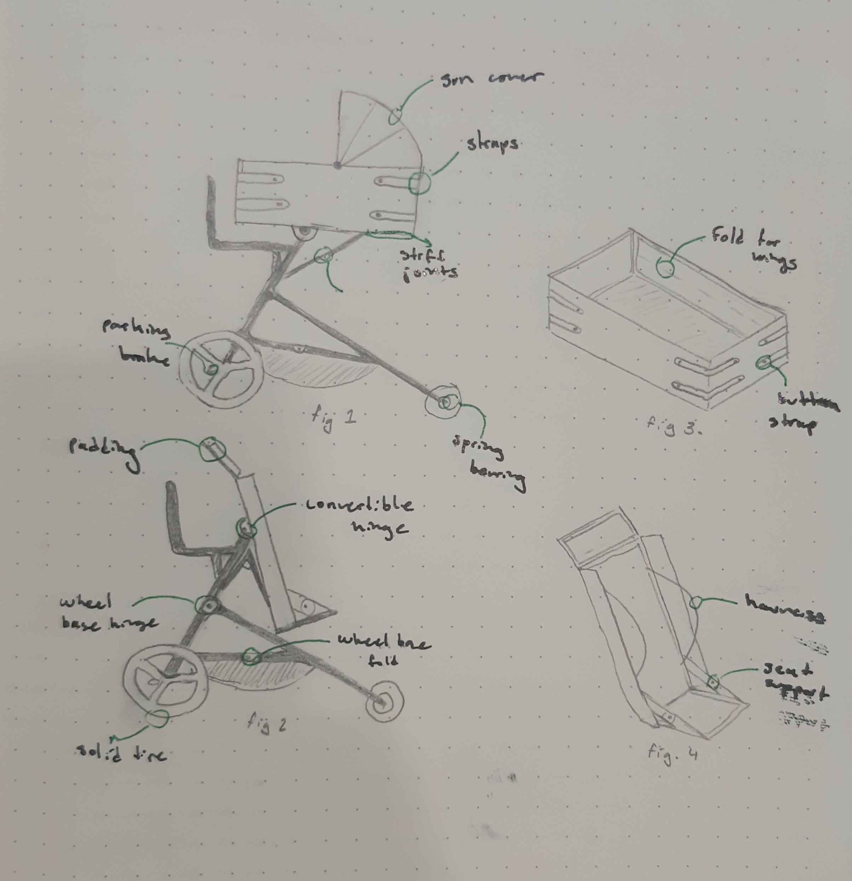

**Description**

Shown is a design concept for a stroller with the ability to convert to a baby carriage for younger children/infants. The primary objective of this design (and also the largest hurdle) is to create the convertible mechanism. This design uses a pin joint and hinge joint to tilt the carrier forward and create a seat (note fig. 2, transformation diagram). This complies with the regulations by having a cover and switch to engage joint motion, giving two distinct actions for folding. The seat is the second large change necessary for the conversion. In essence it is a rectangular prism with the ability to fold down all its sides. In carriage mode, the sides are folded and attached together, making a secure space for the infant to lie down in. The hinges for the sides are stiff, so while they are flexible it is not possible to move them without intentional effort. As well, the sides are connected with buttoned straps(two for each connection) further securing the position. The inside is padded and well connected. When converted, the sides open up into the seat position. The side wings fold in half, giving more space for seating while still giving protection on the sides.

Another large challenge was getting the stroller to fold for storage. This was done with two hinge joints between the front and rear legs. These joints also support the included storage. The wheelchair uses the pin joint in the center to fold flat. As well, two joints near the handles allow for the top part to fold down as well. The seat can go flat, allowing for access.

The wheelbase and wheels are designed to meet the maneuverability and functionality requirements. The rear wheels are on a fixed axle, and are large for good terrain movement. They also ride on spring bearings, giving a smoother ride. The front wheels are able to swivel freely, giving the stroller a very tight turning radius. Both sets come with solid tires, preventing the issue of punctures or leaks. They also have deep treads, giving better grip.

Materials used are all sustainable. The frame is made out of recycled aluminum, as it is both strong and light while being inexpensive. The seat and other fabric components are made out of replaceable spill-proof fabrics that are both durable and comfortable.

**Usage Scenario**

1. Setup
   1. Place folded intervention on ground wheels down
   2. Remove pin joint cover
   3. Press latch, and unfold the top half upright
   4. Continue holding the latch, unfold the wheelbase into its normal position
   5. Set seat to correct position, adjust as necessary
2. Use
   1. Place occupant in crib/seat
   2. Adjust restraints so the occupant is comfortable yet secured in place
   3. Adjust cover to liking
   4. Stand behind intervention, hold on to handlebar
   5. Disengage the foot parking brake, push
   6. Place items in the storage below
   7. Unfold/fold seat to meet needs
      1. Remove pin joint switch cover, press switch
      2. Tilt seat downwards from carriage position, making sure hinge joint is bending
      3. Unclasp each strap, storing them in provided pouch
      4. Fold side wings, bend sides to form headrest and seat
      5. Secure seat with straps
3. Put-away
   1. Remove occupant from seat
   2. Remove pin joint switch cover, depress switch
   3. Fold top half downwards, compress wheelbase
   4. Store intervention

| Demand Type | US Step #  (Most Demanding Task) | Demand Level | notes |
| --- | --- | --- | --- |
|  | **SET UP** |  |  |
| Perceptual | 1b - Remove pin joint cover | 2 | Requires vision and touch |
| Cognitive | 1e - Set seat to correct position | 3 | Sequence needed, remembering positions |
| Physical | 1d - Unfold wheelbase into normal position | 3 | Bending, some physical exertion |
|  | **USE** |  |  |
| Perceptual; | 2e - Disengage parking brake | 1 | Bright red, easy to see/feel |
| Cognitive | 2g - Unfold seat | 3 | Multiple steps, adjustment |
| Physical | 2f - Place items in storage | 2 | Bending, easy to reach though |
|  | **PUT AWAY** |  |  |
| Perceptual | 3b - Remove pin joint cover, depress switch | 2 | Requires vision and touch |
| Cognitive | 3c - Fold top half downwards | 2 | Easy to do, requires 2 steps |
| Physical | 3d - Store Intervention | 2 | Can require lifting |

## design Concept 5

Khiem Nguyen’s Design Concept

Description

This design of the stroller focuses on multi-functional versatility combined with eco-friendly materials, enabling it to grow with a child from an infant to a toddler. It features a convertible seat that converts between two modes for easy transformation from a baby carriage for infants to a toddler seat for long-term use. The frame features recycled aluminum, combining durability with lightweight handling. The Stroller uses an advanced one-hand fold mechanism for easy storage. The smart brake lets it stop with maximum safety through hand- and foot-operated systems. The wheels are adapted to different terrains because of the big wheels in the back for added stability and 360-degree swiveling wheels in the front for tight maneuverability. Under-seat expandable storage for different storage needs with detachable compartments for added convenience is designed within this stroller.

Usage Scenario

Setup:

1. Place the stroller on the ground with the wheels down.
2. Unlock the chassis and unfold the seat to the desired position (cradle or toddler seat).
3. Adjust the handlebar to suit the user’s height.
4. Engage the smart brake system for safety checks before use.
5. Use the one-hand fold mechanism if storing the stroller after setup.

Use:

1. Place the child securely into the convertible seat.
2. Adjust the seat to fit the child’s size, ensuring seatbelts are fastened properly.
3. Push the stroller with ease, even on uneven surfaces, as the terrain-adaptive wheels provide stability and maneuverability.
4. Use the under-seat storage to carry essential items, detaching compartments as needed for convenience.
5. Utilize the smart brake system with either hand or foot to stop the stroller when necessary.

Put Away:

1. Remove the child and items from the seat and under-seat storage.
2. Engage the foot brake to keep the stroller stationary.
3. Press the folding button on the handlebar and gently push down.
4. The front of the stroller will collapse, with the seat and front wheels folding inward.
5. Move to the middle of the stroller to continue pushing down as the handlebar and frame fold inward.
6. Secure the folded stroller by engaging the locking latch if available.
7. Store the stroller in a secure place, ensuring it's locked and compact.

Product Use Demands Analysis Table

| **Demand Type** | **US Step # (Most demanding task)** | **Demand Level** | **Notes (including what drives the demand)** |
| --- | --- | --- | --- |
| **SET UP** |  |  |  |
| Perceptual | 2 – Unfolding the seat into the correct position | 2 | Requires vision and touch to adjust the seat into the cradle or toddler mode. |
| Cognitive | 3 – Adjusting the handlebar to match user’s height | 1 | Requires understanding of how to adjust the handlebar for ergonomic use. |
| Physical | 1 – Placing the stroller on the ground and unfolding | 2 | Some physical exertion is needed to unfold and position the stroller properly. |
| **USE** |  |  |  |
| Perceptual | 2 – Adjusting seatbelt and seat for child safety | 2 | Visual confirmation and tactile input are required to secure the child. |
| Cognitive | 5 – Using the smart brake system during operation | 2 | Requires decision-making and coordination for stopping the stroller safely. |
| Physical | 3 – Pushing the stroller over uneven terrain | 2 | Terrain-adaptive wheels ease the task, but pushing over rough ground requires some force. |
| **PUT AWAY** |  |  |  |
| Perceptual | 1 – Ensuring the child and items are removed | 2 | Visual check to confirm nothing is left in the seat or storage. |
| Cognitive | 2 – Folding the stroller using the one-hand fold mechanism | 2 | Following the correct sequence for folding the stroller is necessary. |
| Physical | 3 – Storing the stroller | 2 | Light physical effort is required to fold and store the stroller. |

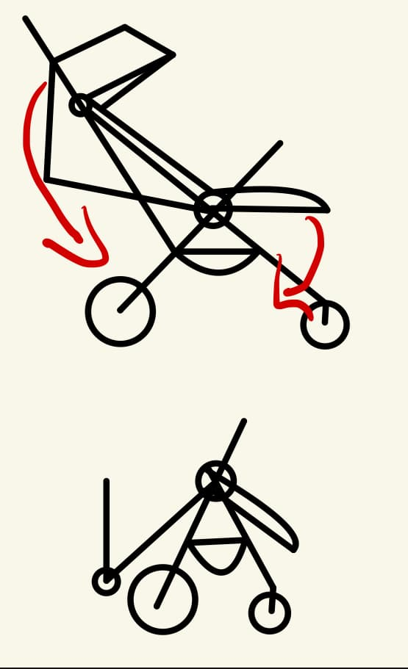

Folding mechanism

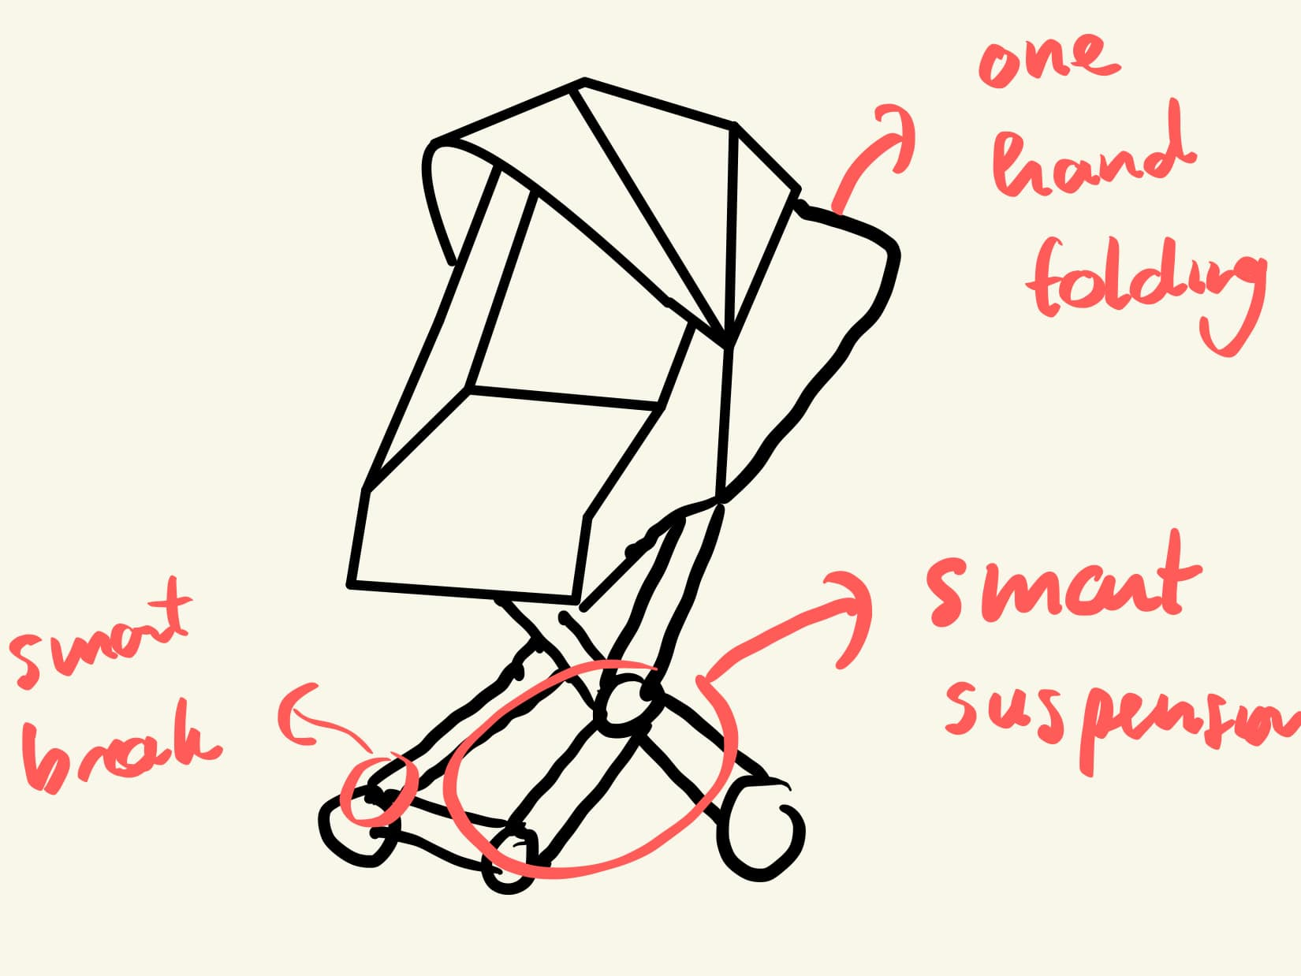

## design Concept 6

Yee Yin Kwok’s Design Concept

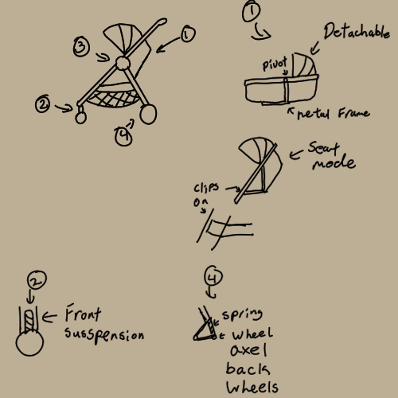

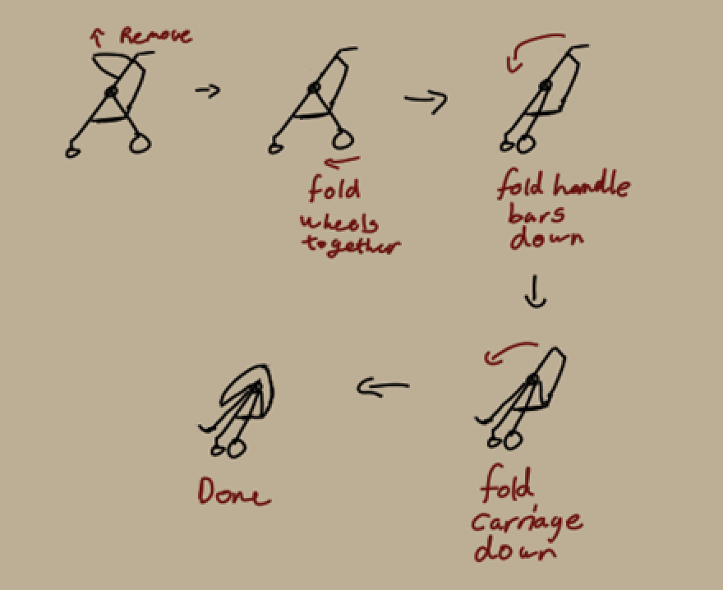

Description:

This design concept is for a transforming stroller that allows for a variety of age ranges to utilize whilst not compromising on storability. A main feature of this design is the convertible stroller carriage that transforms from a baby carriage to a stroller seat. A metal frame runs underneath and to the side of the carriage providing excess support and stability. When the user wants to turn the carriage into a seat, simply rotate along the pivot and lock the pivot in place. The excess fabric can then be folded away and held back using velcro.

The storability of the stroller was another issue that was present as a stroller is quite large and space attentive. As a result, this design aims to solve that problem by having a single large pivot that allows the entire stroller to fold about this point. This allows for a simpler process of collapsing the stroller and allowing the stroller to fold flat.

Comfort whilst a passenger is in the stroller was also a concern whilst designing this as the purpose of this stroller was to allow for it to be used in many different terrain. As a result suspension was added to the wheels to help lessen any change in the terrain. In this design internal wheel suspensions were added in the front rotation collumb, which allows for the front wheels to rotate freely whilst dampening any bumps. The rear suspension is much simpler as the wheels are fixed, allowing to have the suspension be two separate parts held at a joint with a spring to act as the suspension.

The entire frame of the stroller is aluminum allowing it to be lightweight yet durable and corrosion resistant. Underneath the carriage will be a storage compartment made from polyester netting which is durable and water resistant. The carriage will be made from a mix of polyester and wool to allow for comfort and breathability, whilst the outside is water resistant.

**Usage scenario**

1. Setup
2. Place the stroller wheels down
3. Pull the wheels apart till they click in place
4. Unfold the stroller carriage till it clicks in place
5. Unfold the handle bars till it clicks in place
6. Adjust the carriage into the preferred mode
7. Attach carriage cover if desired
8. Use
9. Place passenger into the carriage
10. Secure the passenger
11. Adjust the cover as needed
12. Begin to push the stroller
13. Use the storage compartment when needed
14. Put away
15. Remove the passenger and ensure that there is nothing left in the carriage
16. Unlock the joint and begin to fold the wheels together
17. Then fold the handle bars over
18. Fold the carriage over and store away

| Demand Type | US Step # (Most demanding task) | Demand Level | Notes |
| --- | --- | --- | --- |
|  | **SET UP** |  |  |
| Perceptual | 1b/c/d | 2 | Use of touch and vision to ensure stroller is properly sacred |
| Cognitive | 1e/f | 3 | Familiarity with how the carriage conversion and sunroof work |
| Physical | 1a/b/c/d | 3 | Heavy lifting, and forceful manipulation is required with the help of two hands |
|  | **USE** |  |  |
| Perceptual | 2d | 3 | Good spatial awareness is required |
| Cognitive | 2d | 3 | Hand eye coordination is require as well as quick cognitive function |
| Physical | 2d | 2 | A strong force may be required to get the stroller moving depending on the weight of the contents |
|  | **PUT AWAY** |  |  |
| Perceptual | 3a | 3 | Ability to see whether or not it is safe to collapse the stroller |
| Cognitive | 3b | 2 | The ability to understand the step required to collapse the stroller properly is required |
| Physical | 3b/c/d | 3 | A reasonable amount of force will be required to collapse and store away the stroller |

# 

# Loop 2

## design concept 1

Osman Asif’s design concept

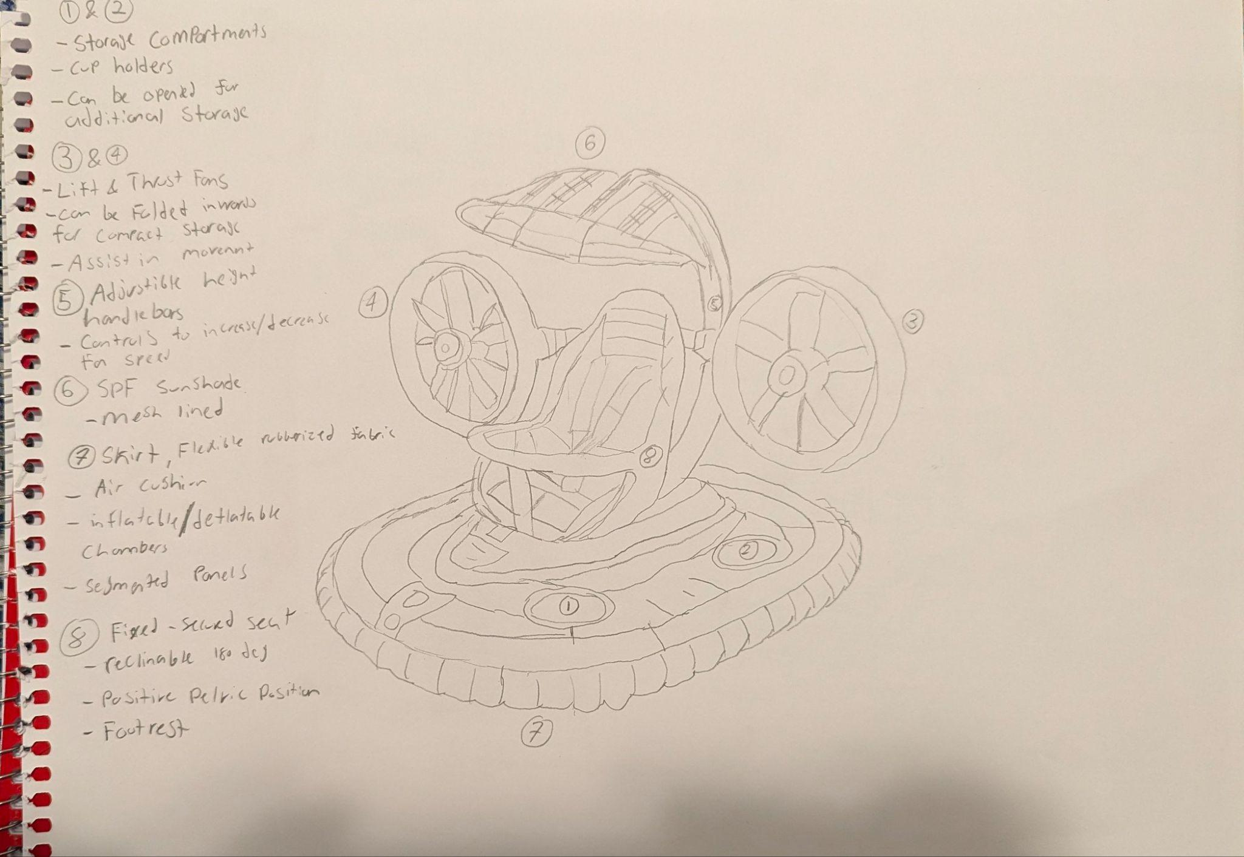

**Description:** The advanced intervention integrates comfort, functionality and usability in a high-tech manner. The intervention includes various modular components aimed at providing ease of mobility and stability across long travels. The intervention features thrust & lift fans positioned on either side in order to add a propulsion system to aid significantly in movement. Additionally the fans can be adjusted for different heights allowing for adaptation to various terrains and as well as folded inwards for compactness. Furthermore, the adjustable handlebars behind the fans allow for adjusted height and length when pushing the intervention allowing for a comfortable position for the user, it also includes controls for the fan speed and on/off controls for the fans if they are not needed or are required to spin faster. Moreover, the air cushioned skirt, creating the base of the intervention works alongside the fans, similarly to a hovercraft in order to create a frictionless area to allow for a smooth ride through rough terrain. Furthermore, the skirt is made of flexible, rubberized fabric that has air cushioning and inflatable/deflatable air chambers that can be adjusted for compactness. The intervention has two storage compartments that can be used as cup holders or opened for greater storage access to hold essential items for the child or the parent. The sunshade using mesh-lining allows for protective material against UV rays for the child and creates a safe environment for them. Lastly, the seat is securely fixed and possesses fastened seat belts ensuring maximum safety as well as reclinable options up to 180 degrees, ensuring a positive pelvic position.

To improve from design 1, design by analogy was used, in order to implement a design that allows for easy mobility of the intervention, by using aspects from a hovercraft, the thrust fans and the air skirt in order to create a smooth, innovative design. Through the use of design by analogy the intervention uses the fans in order to propel forward and aid in pushing it, furthermore, the use of the air skirt allows for a smoother, frictionless ride over different terrains with improved comfortability and ergonomics.

**Usage Scenario**

1. Setup
2. Unfold the thrust fans fully outwards and lock into place, positioning them parallel to the seat
3. Adjust the height of the fans as well as the handlebars to ensure comfortable position
4. Inflate the skirt for use and shock absorption
5. Adjust the sunshade canopy position in order to accommodate the child's needs
6. Adjust the modular seat position
7. Place the child inside, with the safety harnesses on tightly
8. Store any essential items in the storage compartment
9. Use
10. Use the controls on the handlebars to adjust the fan speed as needed for assistance in propulsion
11. Push the intervention forward using the air cushioned flexible skirt, providing a frictionless, smooth ride, absorbing shocks and bumps
12. Use a control on the handlebar to spin fans in the opposite direction of travel in order to act as a means to impede motion and act as a braking system
13. Put away
14. Remove child from intervention, ensuring the seat is locked in a fixed position
15. Deflate the air cushion for compactness
16. Fold in the fans towards the seat and lock them in place, lower the height to the lowest setting
17. Release the three locks on the frame of the seat, bringing it forward and locking it in place
18. Place the intervention in storage ensuring it is secure and stable

## 

## design concept 2

Osama Noureddin’s Design Concept

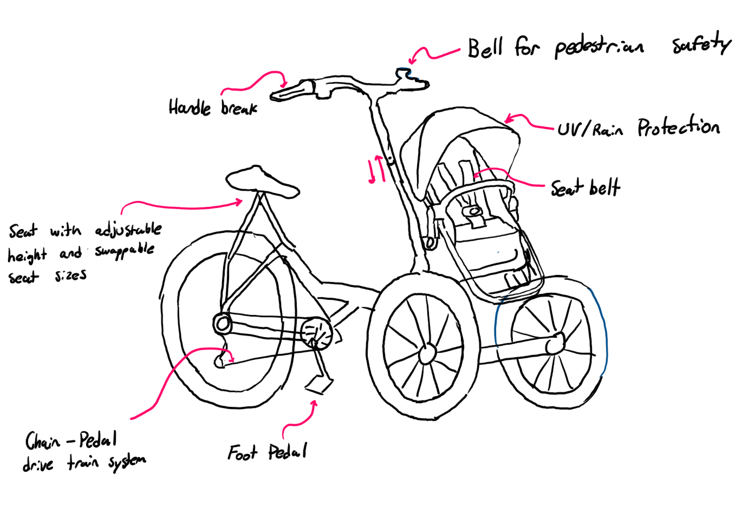

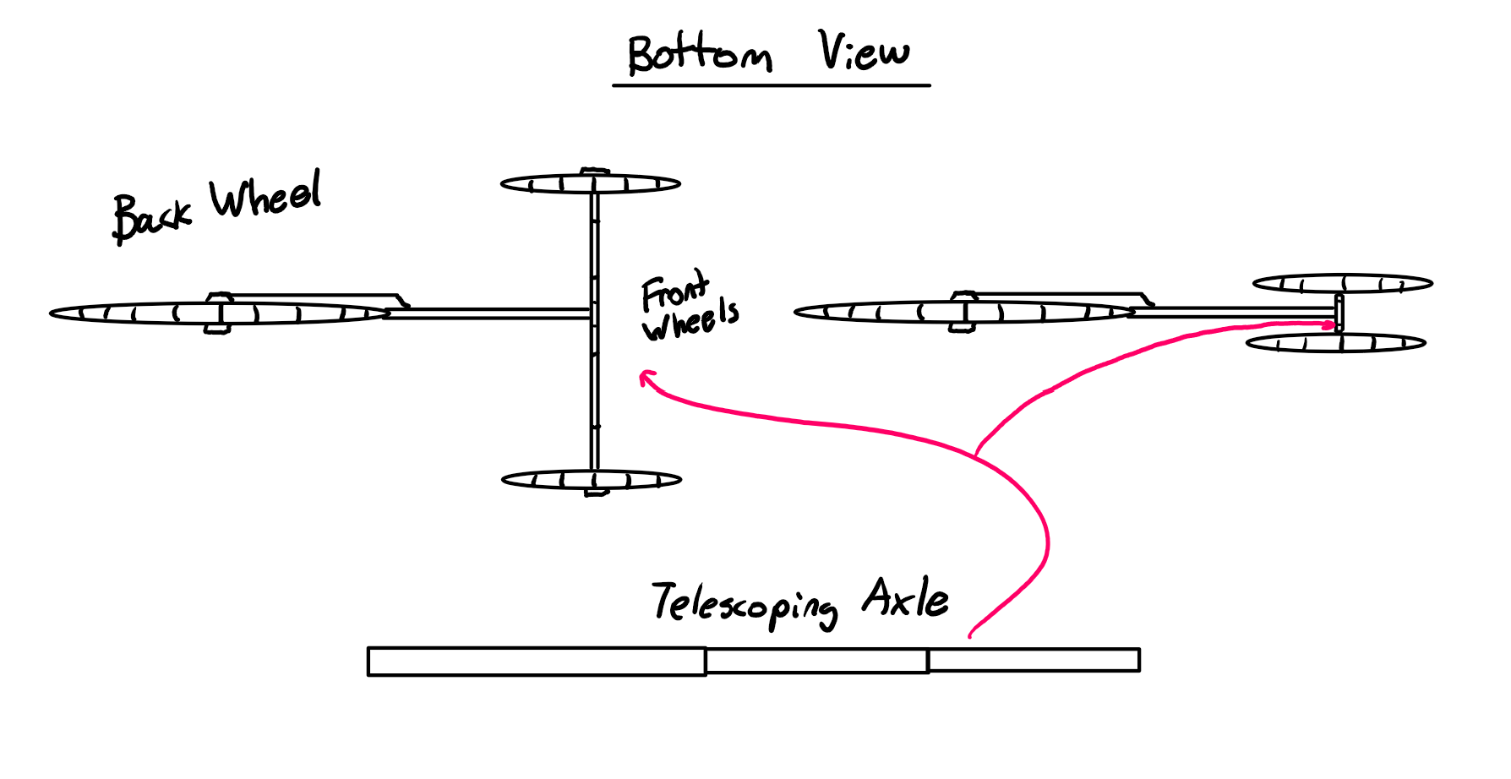

**Description:**

The featured intervention is a three wheeled pedal vehicle with a child seated at the front. The design is ideal for traveling long distances at higher speeds without much effort, and is ideal for commuting. The 2 front wheels are smaller in size than the back wheel and remove the need for balancing such as in a bicycle. To accommodate for various users, the intervention features a swappable seat for either larger or smaller surface area depending on user’s bottom breadth, as well as adjustable seat and steering bar heights. For safety considerations, the intervention features rim brakes activated via a handlebar trigger, a bell to alert pedestrians, as well as a seatbelt for the child passenger/infant passenger. For ease of storage, the front axle of the intervention is telescoping such that the distance between the front two wheels can be reduced to take up less space. Only the rear wheel of the vehicle is powered by pedaling, and featured is a 7 gear system controlled by a rotary dial on the right handlebar, in which the lowest requires the least amount of force to pedal but also produces the least torque. A creativity method used to transition from the previous design iteration is **design by attribute**, in which the previous method of pushing and walking with the intervention was replaced by pedaling.

**Usage Scenario:**

1. Setup
   1. Pull apart front wheels until they lock in place
   2. Adjust seat and handlebars as necessary by pressing on spring buttons and pulling/pushing until desired setting
   3. Seat child in vehicle seat and harness seatbelt
   4. If necessary, adjust canopy such that child is protected from weather conditions
2. Use
   1. Sit on seat with hands on handlebars, fingers over breaks and feet on pedals
   2. Begin pedaling and steering intervention in desired direction
   3. To slow down, squeeze breaks
   4. After reaching a comfortable speed and pedaling becomes too easy, turn gear dial towards user to increase gear level
   5. When finished with ride, bring gear level back down to lowest before returning and parking
3. Put-Away
   1. Unbuckle and remove child from vehicle
   2. Press spring buttons on axle and collapse the wheels together
   3. Store intervention where desired

## 

## design concept 3

Codin Nguyen’s Design Concept

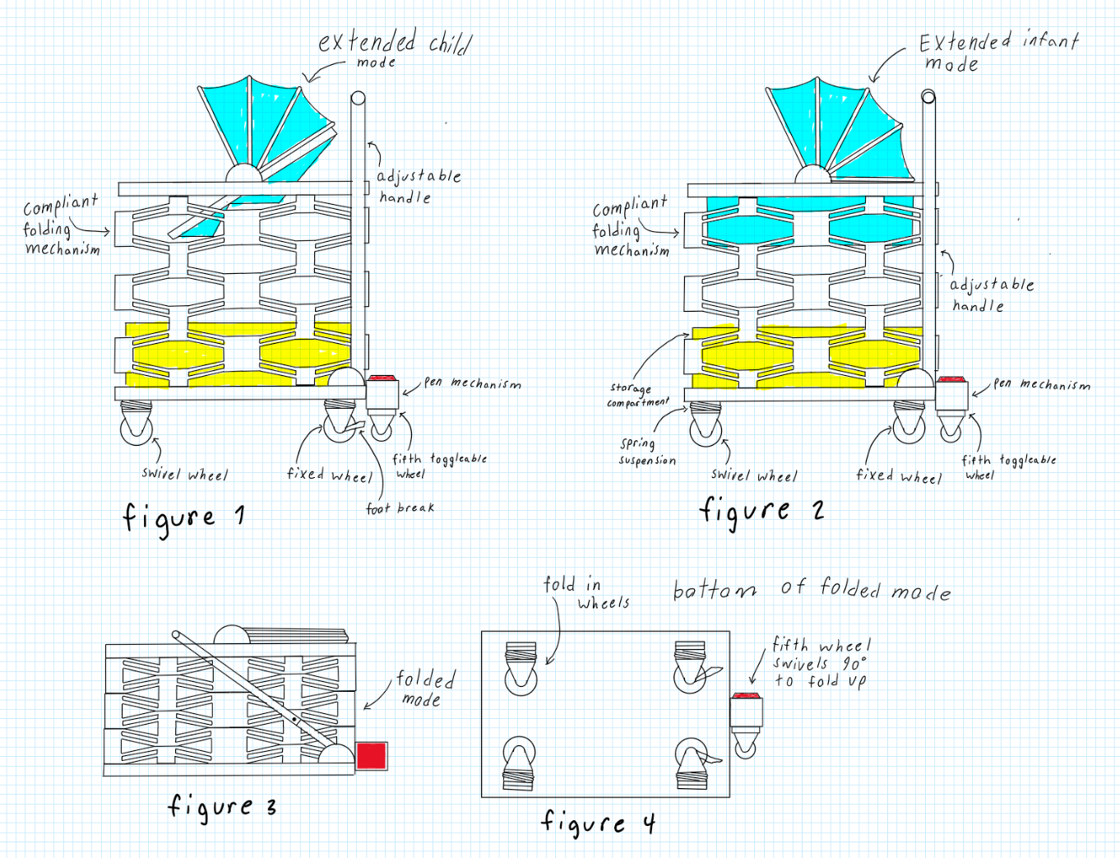

**Description:**

The design concept sketch introduces a five-wheel intervention with innovative features, including a transformable seat that shifts from a basket to a seat with a 40-degree incline (see Figures 1 and 2). This adaptability allows the intervention to accommodate a growing child over multiple years, eliminating the need for frequent replacements. A key feature is the deployable fifth swivel wheel, activated by pressing a red button. When deployed, the intervention balances on the fifth wheel and the two front swivel wheels, enabling omni-directional movement, which is ideal for navigating confined spaces like public transport (see Figures 1 and 2). Pressing the red button again smoothly retracts the fifth wheel, similar to a retractable pen. When the fifth wheel is disengaged, the intervention operates on two front swivel wheels with positive caster (see SKB 5.5 for caster specifications), while the two rear wheels remain fixed. The design also includes a reliable compliant folding mechanism with foldable wheels for compact storage. Foot brakes on each rear wheel (see Figures 1 and 4) provide secure locking—an essential feature for safety on inclined surfaces or public transport. An integrated seatbelt further enhances safety, preventing toddlers from falling out while the intervention is in motion.

**Usage Scenario:**

1. Setup
   1. Fold Out the wheels
   2. Rotate the fifth wheel to be vertical
   3. Pull back handle to 1 o'clock position
   4. Press on handle side lock then extend handle out wards
   5. Extend the main body upwards
   6. Push handle to 12 o'clock position to lockin the main body
   7. Adjust seat to desired mode either small child mode or infant mode
2. Use
   1. Place child into the seat
   2. Secure child with the straps if in small child mode
   3. Adjust sunshade to desired coverage
   4. Place essential items in storage compartment located under to child seat
   5. Push the intervention by the handle to control and move the intervention
   6. When extra maneuverability is needed, step on the red button to activate the fifth wheel to deactivate the fifth wheel step on the red button again.
   7. Step on foot brake to anchor the intervention in place to unanchor the intervention lift the foot brake
3. Put away
   1. Remove child and essential items from the seat and storage compartment
   2. Adjust seat into infant mode
   3. Pull back handle to 1 o'clock position
   4. Collapse the main body down to its lowest position
   5. Collapse the handle
   6. Push the handle to the 10 o'clock to lock in the main body
   7. Rotate the fifth wheel to be horizontal
   8. Fold in the wheels

## 

## design concept 4

Andrej Draskovic’s Design Concept

## 

**Description:**

The intervention is an assistive child carrying device to be used for moving or transporting a child. Its most prominent feature is the magnetic levitation suspension system (Figure 1). Using opposing magnets on the base and the main unit, the intervention can levitate. This system creates a smoother ride. Another large feature is the chest/stomach pushing area. Instead of relying on purely arm strength, the user can use their whole body to move the intervention, allowing for a greater user base. The pushing area is adjustable for height, as well as chest area. As well, the intervention uses a hybrid power system, assisting motion with two electric motors. These can be controlled using the two handles (Figure 3). Controls include an accelerator, brake, parking brake, and folding activator. All are easy to press and use. The folding mechanism is seemingly complicated with many moving parts, but all it requires is a press of the folding button. This electronically unlatches all the folding joints and turns off the magnetic levitation, allowing the two parts to be separated. The intervention then folds with a simple downwards push. The child carrying area is comfortable and large, allowing children of many ages and sizes to lie flat. The included sunshade protects from the weather and other elements. For storage, the large empty area under the child carrying area has netting, allowing for many large items to be stored. As it is not too low to the ground, minimal bending over is required.

In order to differ and improve the design from Milestone 1, several creativity methods were used. When coming up with the magnetic levitation suspension system, analogical design was used. Imagine driving a car that was so smooth, you would not feel anything from the road. The same concept can be applied to the given intervention. As well, design by attribute was used to come up with the chest pushing system. Swapping the handles for some other device that can utilize more of the body’s strength was the main goal, and pushing with the whole chest/body dawned as a great solution.

**Usage Scenario:**

1. Setup
   1. Recover intervention from storage space
   2. Unplug charger
   3. Press disassembly button
   4. Pull on the top, until all joints latch
   5. Place top part of the intervention on the base, magnetic levitation start
2. Use
   1. Place child into carry area
   2. Adjust sunshade as necessary
   3. Place any items in the storage area
   4. Place chest on pushing area, and hold both handles
   5. Disable parking brake, initiate accelerator while pushing
   6. To stop, initiate brake
   7. Steer by pushing intervention in desired direction, using motors for assistance
3. Put away
   1. Activate parking brake
   2. Remove child and any items stored within the intervention
   3. Activate folding button
   4. Remove magnetic levitation base
   5. Push down on intervention, making sure nothing snags while folding

## 

## design concept 5

Khiem’s design concept

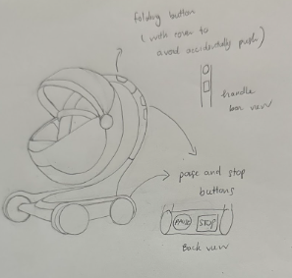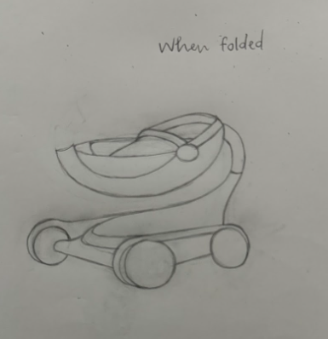

**Description:** It features an ergonomic, curved handle for easy steering and a built-in folding button that triggers a smooth, automatic fold. With a single press, the vertical support bar collapses downward, and the egg-shaped seating pod folds up over the base, creating a streamlined, easy-to-carry shape. For added convenience, each button on the pod provides audio feedback with spoken confirmations, which is especially helpful for users with visual impairments or anyone who prefers an extra layer of confirmation. The pod is weather-resistant and built with shock-absorbing materials, ensuring a smooth ride over wet or bumpy city streets. The device offers two braking modes for added safety and flexibility. In the “pause” mode, the device will temporarily halt, but it can resume movement if pushed with enough force. The second mode, a full stop, keeps the device stationary until the user presses the button again to resume motion. Additionally, slight motorized assistance reduces the physical effort needed, making it easier to navigate crowded sidewalks and inclines with minimal strain. Its low-profile, egg-like shape balances style, stability, and comfort, providing a modern and practical solution for urban baby transportation.

**Usage Scenario:**

1. Setup

* **a.** Unfold the pod by pressing the unfolding button; the vertical support bar will extend, and the egg-shaped seat will rise and lock into place.
* **b.** Adjust the handle height for a comfortable grip and ensure the ergonomic handle is positioned for one-handed use.
* **c.** Engage the shock-absorbing base to provide a smooth, stable ride over uneven surfaces.
* **d.** Adjust the sunshade canopy to provide optimal coverage based on lighting and weather conditions.
* **e.** Position the modular seat for comfort and security, adjusting as necessary for the child’s height and needs.
* **f.** Place the child in the seat, securing them with the harness to ensure a snug and safe fit.
* **g.** Store any essential items, such as bags or toys, in the designated storage compartment.

2. Use

* **a.** Use the handle to steer the pod, with motorized assistance providing a smooth, low-effort push.
* **b.** Adjust speed as needed with the built-in controls on the handle to match walking pace or navigate more challenging terrain.
* **c.** Engage the foot brake to control stops, using the braking system to decelerate smoothly when needed.
* **d.** Steer by applying gentle pressure on the handle; the motor assistance responds to each movement, ensuring smooth directional control.

3. Put Away

* **a.** Carefully remove the child, ensuring the harness is fully unfastened, and empty the storage compartment of any items.
* **b.** Engage the automatic deflation of the shock-absorbing base to compact the pod for storage.
* **c.** Press the folding button; the vertical support bar collapses, and the egg-shaped seat folds upward over the base for a compact shape.
* **d.** Lock the frame and ensure all components are securely in place to prevent accidental unfolding.
* **e.** Place the pod in the designated storage location, ensuring it is stable and ready for the next use.

## 

## 

## 

## design concept 6

Yee Yin Kwok’s design concept

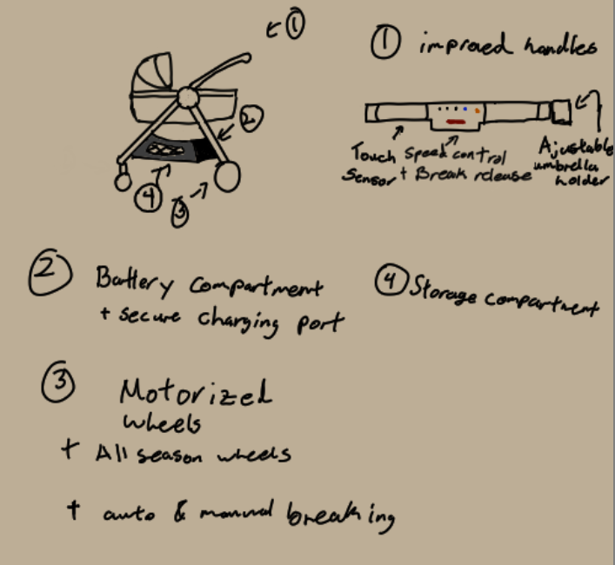

**Description**: The intervention that is featured in this design is the motorized back wheels designed to assist those who may have trouble pushing the vehicle. This also includes wheels designed for all seasons, allowing for better traction during rainy and colder seasons. As a safety precaution, the handle has touch sensors to detect when someone is holding onto the handles. If the user were to suddenly release their hands from the device, the motors will instantly stop and the breaks will be engaged. The motors will have variable speeds that can be cycled through, and an adaptability option, where the speed at which the vehicle will move is based on the force applied to the device. The batteries will be stored above the back wheels to lower the center of gravity whilst operating the vehicle. Above the battery pack will be a safe compartment that can charge your phone and safely lock away any potential valuables. The battery pack will also be detachable for easier charging fast and fast replacement. Beside the battery compartment will be a large general storage compartment made of polyester cloth and mesh. The folding mechanism comes from the center joint where the entire device will fold into a semi flat rectangular prism for easier storage.

**Usage scenario**:

1. Setup
2. Unplug the batteries if charging
3. Unfold the wheels and handles until they click into place
4. Attach overhead shade if desired
5. Attach battery if removed
6. Use
7. Place the child into the carriage
8. Secure the child with the seatbelt
9. Place any desired items into the storage
10. Place hands onto the touch sensors
11. Press the red button in the center of the handle to disengage the brakes
12. Enable or disable assistive walking
13. If enabled set desired speed (default is adaptive walking speed)
14. Begin to push the intervention
15. Put away
    1. Remove hands from the handles
    2. Check if breaks are enabled
    3. Remove child and any items in the storage
    4. Push the folding button
    5. Fold the device
    6. Either remove the battery or leave it in and plug it in to charge
    7. Leave in the desired storage location

1. Only the last 5 digits of the student number are required.